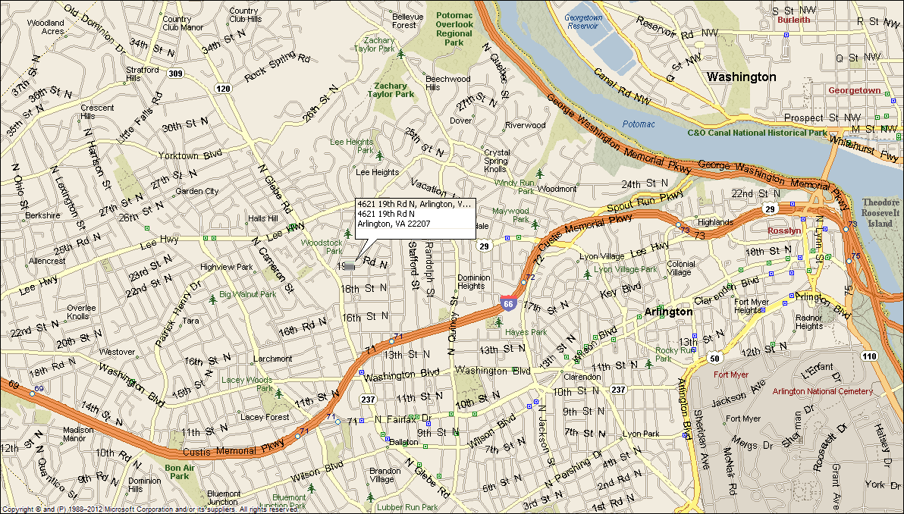
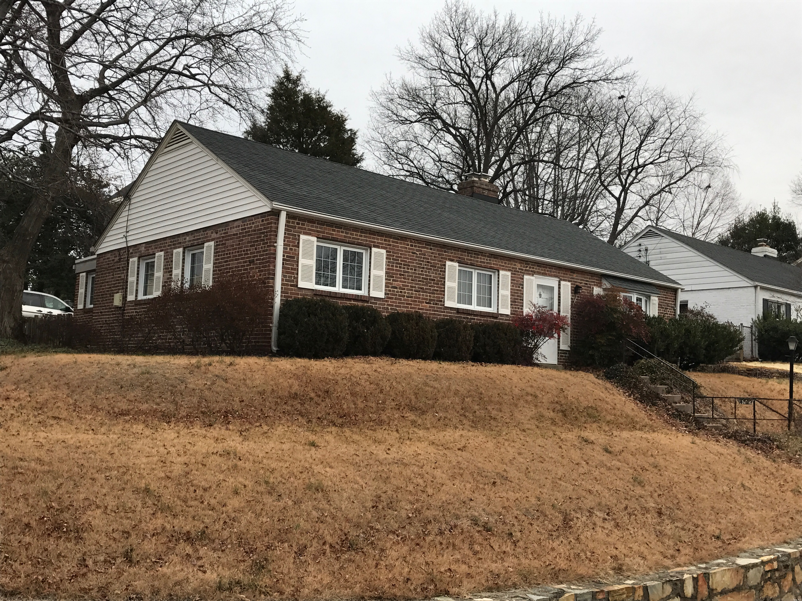
4621 N. 19th Road
Arlington, VA 22207
Classic Brick Rambler
Great location: Walk to Shops & Restaurants, Close to DC (3 miles), Tysons Corner (6 miles), I-66, Rt. 29
- Three bedrooms, two full baths.
- Central a/c, natural gas heat & hot water.
- Newer kitchen w/ SS appliances.
- Off street parking, large landscaped yard, great back yard.
- Original refinished hardwood floors thru out.
- Established quiet, sought after neighborhood.
- Excellent Schools: Glebe Elementary, Dorothy Hamm MS, & W&L HS
- Lease terms: 1 year minimum, no smoking, no use of fire place.
RENT: $2,900.00 / month + utilities, contact Lyndsay Saffer 703-906-3082
Email: safferlyndsay@gmail.com

